**DOCUMENTATION OF REVERSO**

**LOGO OF THE APP:**

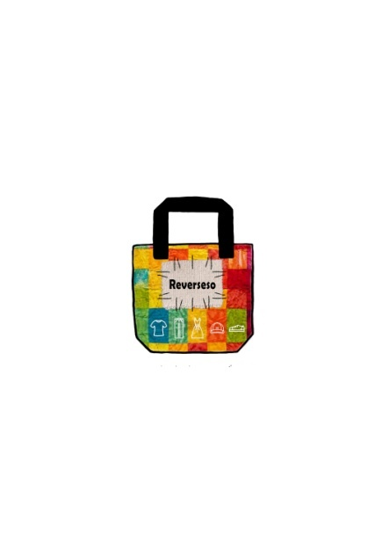

**● Aim &Objective ;** The primary aim of this app is to create a virtual trial room for the online consumers this app is mainly for all who mostly buy their things online and feels annoying to visit shopping mall and also for them who shops most of the things online. It basically focuses on the clothes or we can say outfit and accessories like shades or sunglasses and Scarf’s. Just think for once before buying clothes from online if you can wear and see the clothes how amazing it would be. Just think for once you liked a good outfit on online shopping and you want to buy that outfit but you are confuse whether it would suit you or not. This app will solve that problem in minutes it will create a virtual trial room for you and it will provide you an Analyze how good or bad are you looking at your outfit Which you want to buy and you can also share your virtual trial room images to your near and dear ones to take the view point of them.

**Statement of the problem :**

* The scissor feature fit the clothes on body of user in approx not exactly 100%.
* It will become costly if a customer customize his/her clothes of his/her own choice.

**Limitation :**

* Age above 7 can only try virtual trial room.
* Reverso slot cannot exceed more than 6 slot at a time.

**Minimum Requirement ;**

* Minimum Camera 5 M.P
* Minimum Android 5.0(Lollipop).

**Advantages :**

* Consumes time and space.
* No hidden camera issues.
* Fulfills the shopping of online customers .
* No long tiresome queue.
* Reduces exchange and return rates.
* Shopper gets the 3D view of him/herself.
* Quicker and easier to try clothes yourself in seconds.

**Agile Manifesto :**

**●Individuals and interactions over Processes and Tools:** Interactions with developers or client department for easy interface between user and application i.e. making amateur tools that any age of person can use moderately.

**●Customer collaboration over contract negotiation :** As we will collaborate with our customers and listen to their requirements and will bring update in our project .

**●Working software over Comprehensive Documentation:** We can collab accessing or surfing our application. Collaborating with customer not only give us support for better application but along we get innovative ideas that we can implement in application.

**●Responding to change** **Over Following a Plan:** As we get reviews from user and problems related to application or product, but as ability to making changes decrease & cost increases. By through reviews we can our update application to fulfill customer basic needs and Our team will approach planning, working & giving priorities to feedback/ reviews and giving them a quick change for nil disturbance.

**The kind of problem our app will solve are:**

1. When you buy online you can’t try that outfit or those accessories (shades, sunglasses, scarfs) before buying. You can only try that outfit or accessories when it is received by you which is major disadvantage of online shopping.
2. Often when you received your parcel you find they don’t fit very well. It’s always annoying when a dress is little too big, or when sleeves are awkwardly short.
3. When order has to be returned by you that’s the worst and annoying part of online shopping and hectic job.
4. You have to pay for yours order delivery, and for an item to be returned to the warehouse. So extra expenses is also a headache for the consumer.

For this kind of problems people don’t choose to shop online.

And this kind of problem can be easily solved by our app.

Name as “**Reverso**”

**GITHUB LINK**: https://github.com/shubhamv998/Reverso